PeopleXD holds rules which determine whether or not a given appointment is eligible to be counted towards an employee’s Continuous Service. Those rules must be aligned with the University’s policy around Continuous Service and should be updated whenever this policy changes.

This guide covers the following process steps:

1. Create a new rule 1
2. Amend an existing rule 3
3. Delete an existing rule 4

Core|Portal > People Management > HR Admin Setup and Settings > Organisation Rules > Eligible Service Rules

Create a new rule

- Select “Continuous Service” from the drop-down list.

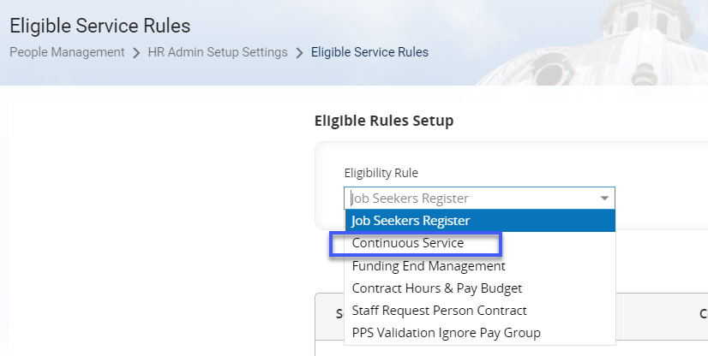

- All the existing eligibility rules will now appear on the screen.

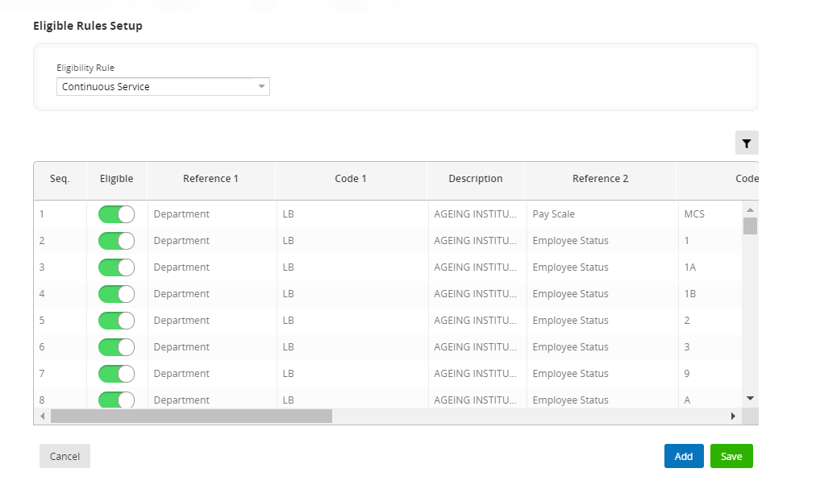

- Click  to insert a new row.

 | Note: The “Seq.” number determines the order in which Core applies the eligibility rules, so you should always add a new rule to the bottom of the list, unless you really need to insert a new rule mid-sequence.

- Click into the “Seq” field to begin and enter the details of the new rule following the guide below:
Field Name | Description | Values
Seq. | Sequence; the order in which rules are applied | Numeric (1-999)  Field limited to 3 characters
Eligible | Are appointments described by this rule eligible for Continuous Service? | Tick box (tick if “yes”, blank if “no”)
Reference1 | The first level at which the rule applies | Company  Management Unit  Department  Cost Centre  Location  Category  Sub Category  Job Title  Employee Status  Pay Scale | Pay Group  Sub Division  Level 4  User Field 3  College Association  Pay Administered By  Post Type  Leaving Reason  Appointment Status
Code1 | The alphanumeric code for Reference1, e.g. a Department code | Determined by what has been selected for Reference1
Reference2 | The second level at which the rule applies | Same as Reference1
Code2 | The alphanumeric code for Reference2, e.g. an Employee Status code | The codes in use are currently limited to:
 |  | MCS  1  1A  1B  2 |  | 3  9  A  L  P
Reference3 | The third level at which the rule applies | Same as Reference1  Field not currently in use
Code3 | The alphanumeric code for Reference2, e.g. a Pay Scale code | Field not currently in use
Break In Service | The number of days that must pass between one appointment ending and another appointment commencing to constitute a “break” in the employee’s Continuous Service calculation. | Numeric (1-999)  Field limited to 4 characters
Break In Service Type | Determines the day of the week on which the days for “Break In Service” will begin to be counted; e.g. if the value is “From Sunday”, an appointment could end on a Tuesday, but the Break In Service countdown won’t begin until the following Sunday. | Any Day  From Sunday  From Monday  From Tuesday  From Wednesday  From Thursday  From Friday  From Saturday
Length of Service | Determines whether the total Length of Service on the appointment should Include or Exclude the “Break in Service” days. | Include Break  Exclude Break
Active | Is this eligibility rule currently active? | Tick box (tick if “yes”, blank if “no”)

- Click  to save your changes.

Amend an existing rule

- Go to Core Personnel and navigate to: Core|Portal > People Management > HR Admin Setup and Settings > Organisation Rules > Eligible Service Rules


- Select “Continuous Service” from the drop-down list. All the existing eligibility rules will now appear on the screen.

- Locate the rule you wish to amend.
(Scroll down the list or click on the filter and enter search criteria)

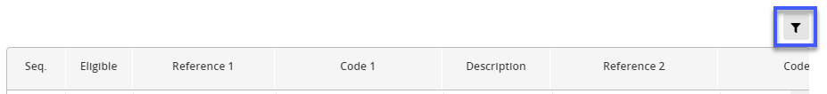

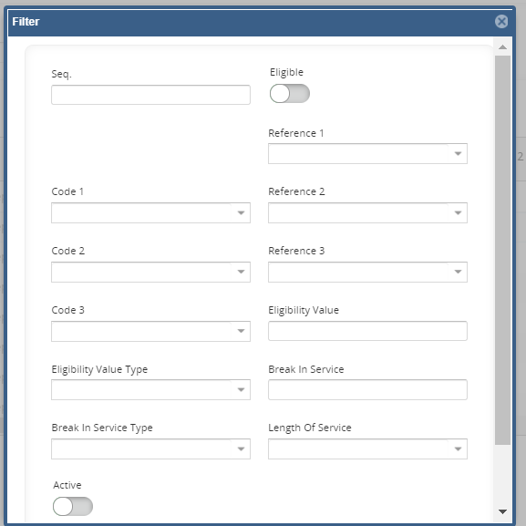

- Edit the fields as necessary. Refer to Section 1 step 4 for a guide to the rule fields.

- Click  to save your changes.

Delete an existing rule

- Go to Core Personnel and navigate to: Core|Portal > People Management > HR Admin Setup and Settings > Organisation Rules > Eligible Service Rules



- Select “Continuous Service” from the drop-down list. All the existing eligibility rules will now appear on the screen.

- Select the rule you wish to delete and scroll to the end of the row. Click on the ELLIPSES (…) and choose Delete.
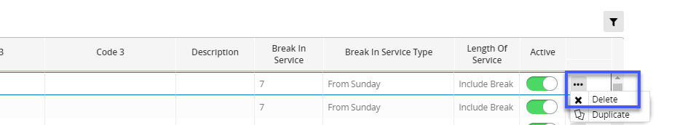

The list of rules will refresh and the deleted rule will no longer appear.
- Click .

 | Note: You can’t “Undo” a deletion, so ensure you’ve selected the appropriate rule before proceeding!

